Picture sized to fill the page:
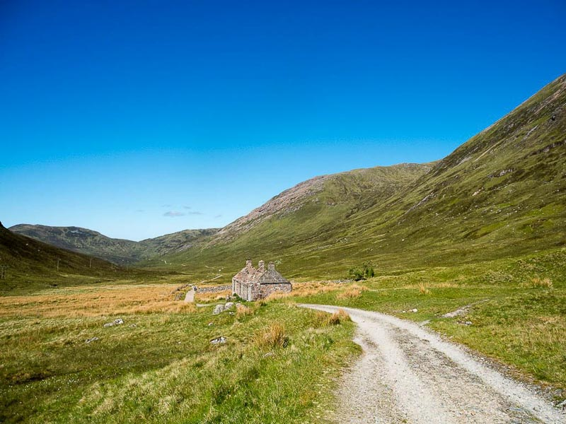
The End.

